Name: Bilal Abid Abbasi
ID:45961
Lab task 1

OOP LAB TASK 2:

1. Temperature Converter (Using Functions and if-else)
#include <iostream>
using namespace std;
double celsiusToFahrenheit(double celsius)
{
return (celsius * 9/5) + 32;
}
double fahrenheitToCelsius(double fahrenheit)
{
return (fahrenheit - 32) * 5/9;
}
int main()
{
double celsius, fahrenheit;
int choice;
cout<<"1. Celsius to Fahrenheit"<<endl;
cout<<"2. Fahrenheit to Celsius"<<endl;
cout<<"Enter your choice: ";
cin>>choice;
if(choice==1)
{
cout<<"Enter temperature in Celsius: ";
cin>>celsius;
fahrenheit = celsiusToFahrenheit(celsius);
cout<<"Temperature in Fahrenheit: "<<fahrenheit;
}
else if(choice==2)
{
cout<<"Enter temperature in Fahrenheit: ";
cin>>fahrenheit;
celsius = fahrenheitToCelsius(fahrenheit);
cout<<"Temperature in Celsius: "<<celsius;
}
else
{
cout<<"Invalid choice";
}
return 0;
}

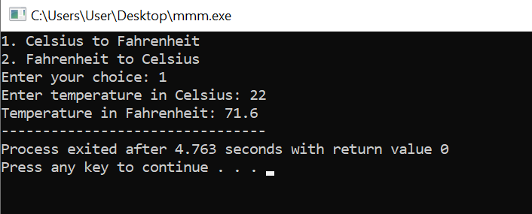

2. Simple Calculator (Using switch case)
#include <iostream>
using namespace std;
int main()
{
double num1, num2, result;
char operation;
cout<<"Enter first number: ";
cin>>num1;
cout<<"Enter operator (+, -, *, /): ";
cin>>operation;
cout<<"Enter second number: ";
cin>>num2;
switch(operation)
{
case '+':
result = num1 + num2;
cout<<"Result = "<<result;
break;
case '-':
result = num1 - num2;
cout<<"Result = "<<result;
break;
case '*':
result = num1 * num2;
cout<<"Result = "<<result;
break;
case '/':
result = num1 / num2;
cout<<"Result = "<<result;
break;
default:
cout<<"Invalid operator";
}
return 0;
}
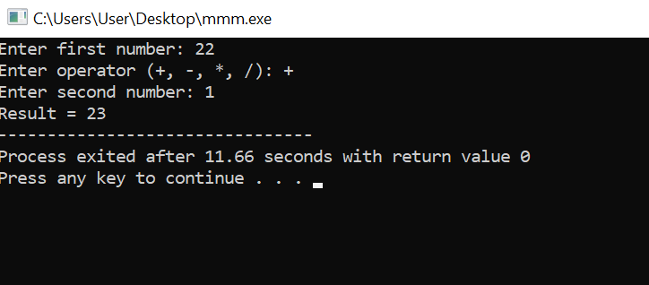

3. Find Maximum and Minimum Number in Array
#include <iostream>
using namespace std;
int main()
{
int n, numbers[100];
int max, min;
cout<<"Enter number of elements: ";
cin>>n;
for(int i=0; i<n; i++)
{
cout<<"Enter number "<<i+1<<": ";
cin>>numbers[i];
}
max = numbers[0];
min = numbers[0];
for(int i=1; i<n; i++)
{
if(numbers[i] > max)
{
max = numbers[i];
}
if(numbers[i] < min)
{
min = numbers[i];
}
}
cout<<"Maximum number = "<<max<<endl;
cout<<"Minimum number = "<<min;
return 0;
}
